**Example:**

1. I have a login application that was running on port **8082**. for fetching the customer details i am using below url. It is using post method,

<http://localhost:8081/find/v1/finByUserId>

1. My wire mock server running on **8080** port.

**Steps to record the request and response from postman.**

1. **Hit this url** (<http://localhost:8080/__admin/recorder/> )

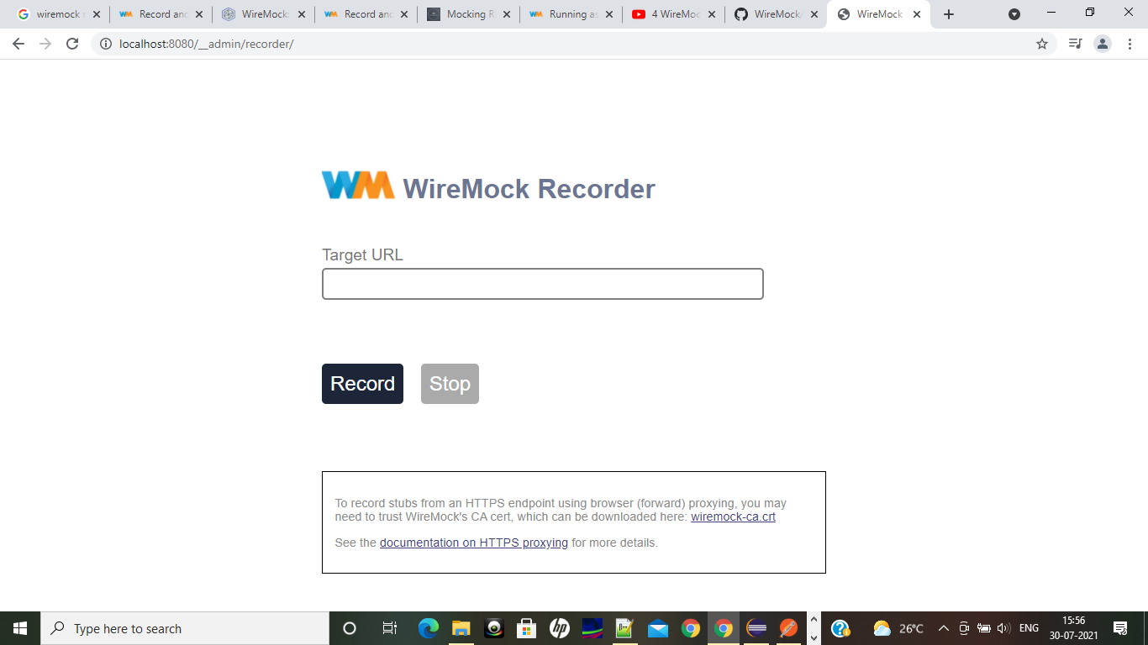

1. **In the above screen in place of target url give the micro service url till** [**http://localhost:8081**](http://localhost:8081)

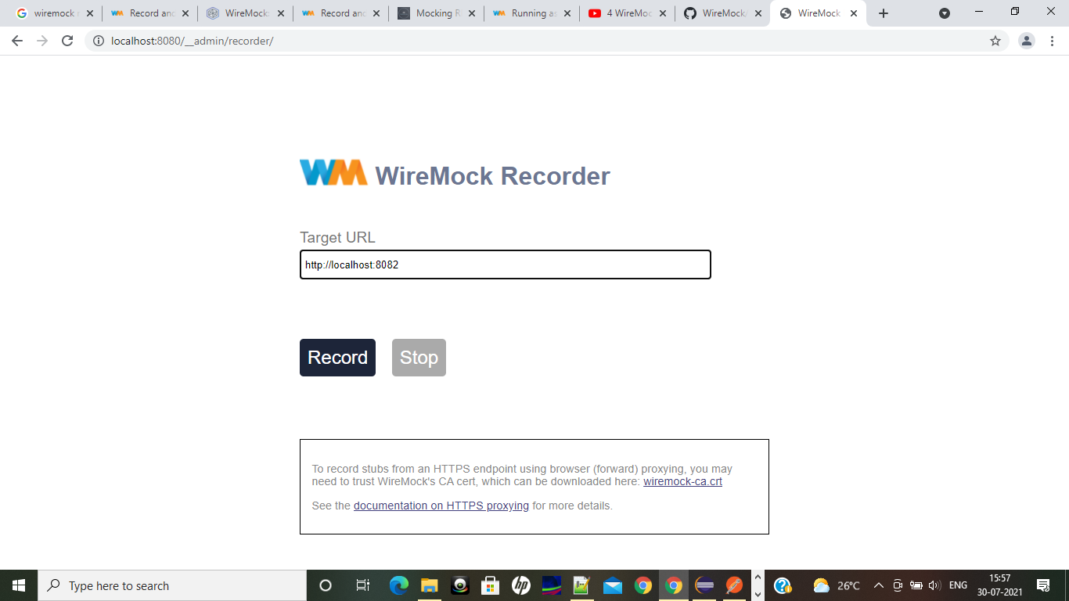

1. **Click on record in above screen.**
2. **In the post man we need to hit the micro service with wire mock server url** (<http://localhost:8080/find/v1/finByUserId> )

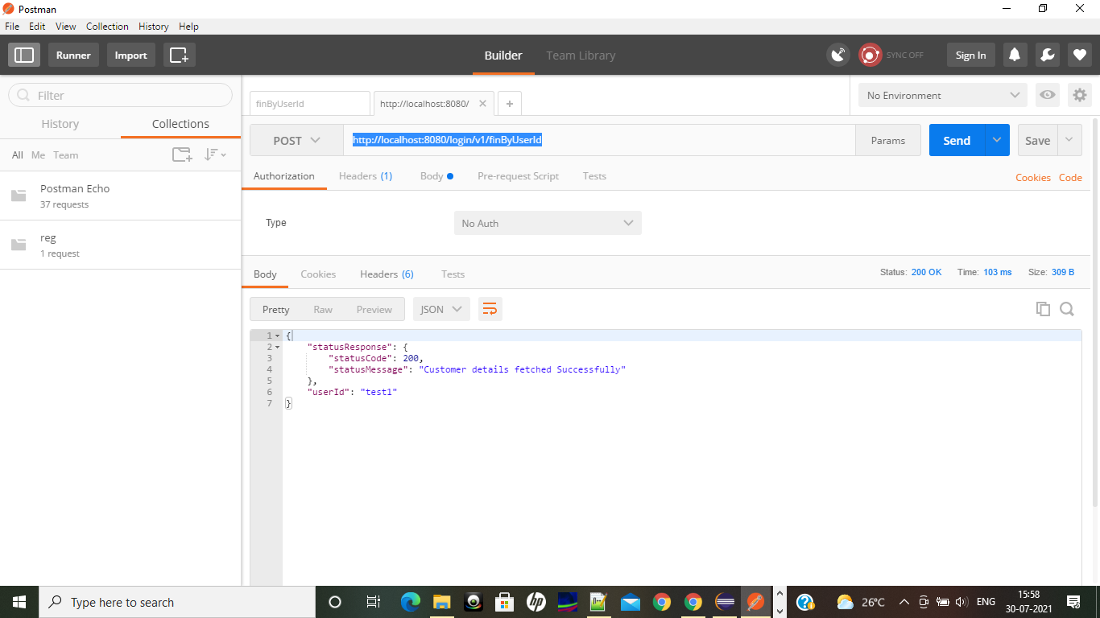

1. **Stop the Recording in wire mock server**

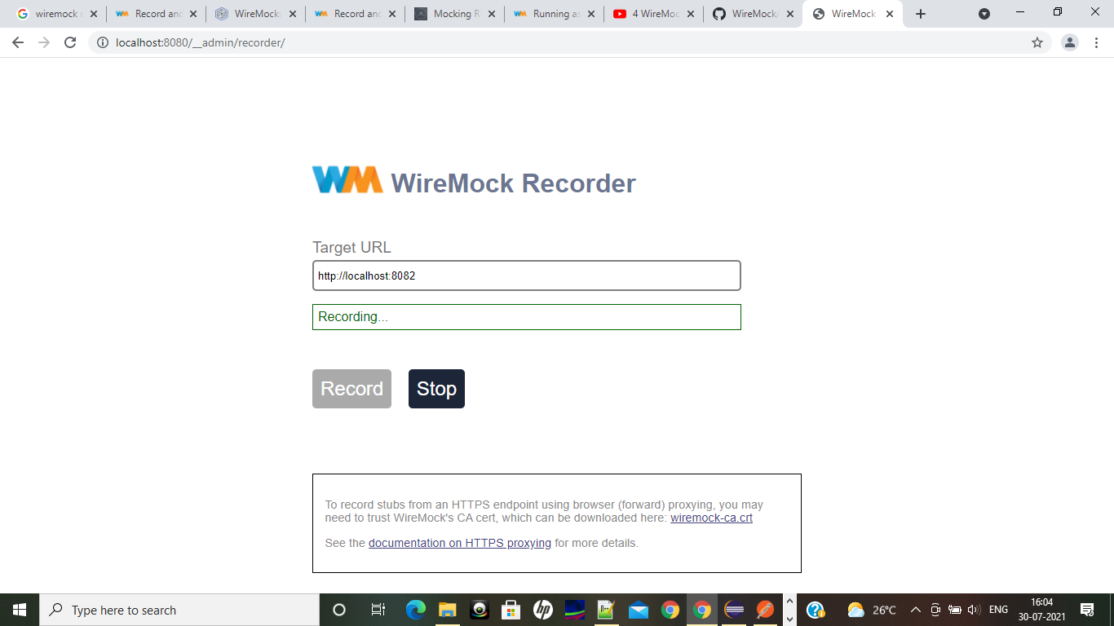

1. **You could see one recording captured,**



1. **You could see the recorded json in mappings folder, where we are running the wire mock server**

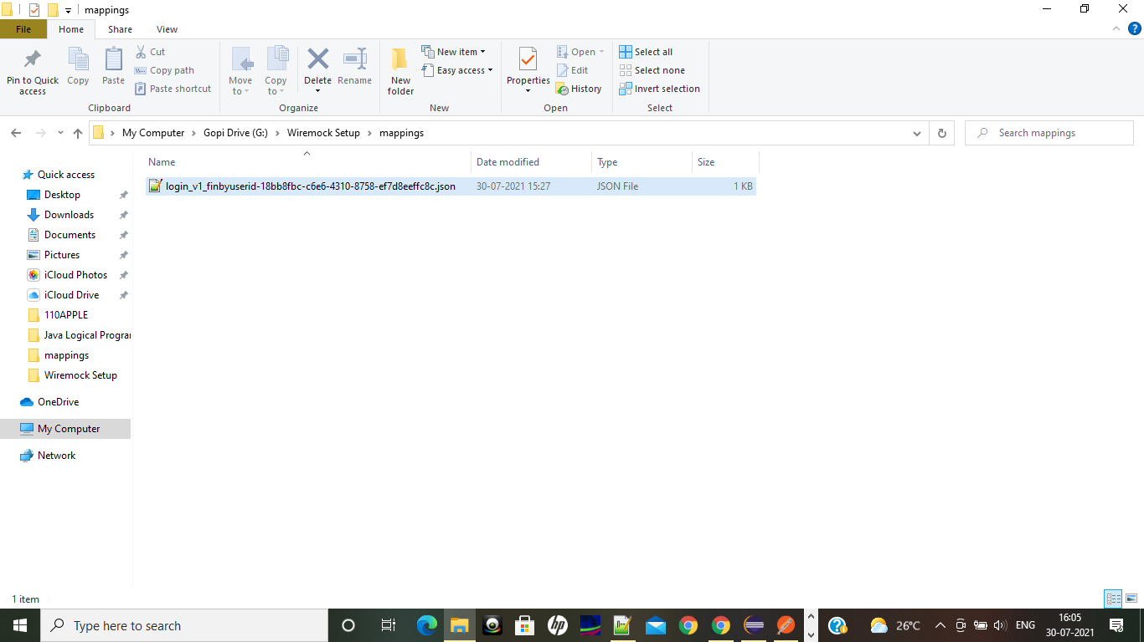

1. For adding the integration test cases we added rest-assured api.
2. My Services are running in these ports **login-service(8082), reg-service(8081) and wire mock server on 8080.** Myrequirement is to invoke the **reg-service** from **login-service** without invoking actual reg-service instead of wire mock server.
3. Recorded reg-service request and response with the help of wire mock recorder.
4. Pasted above recording in login-service **src/test/resources/mapping** folder

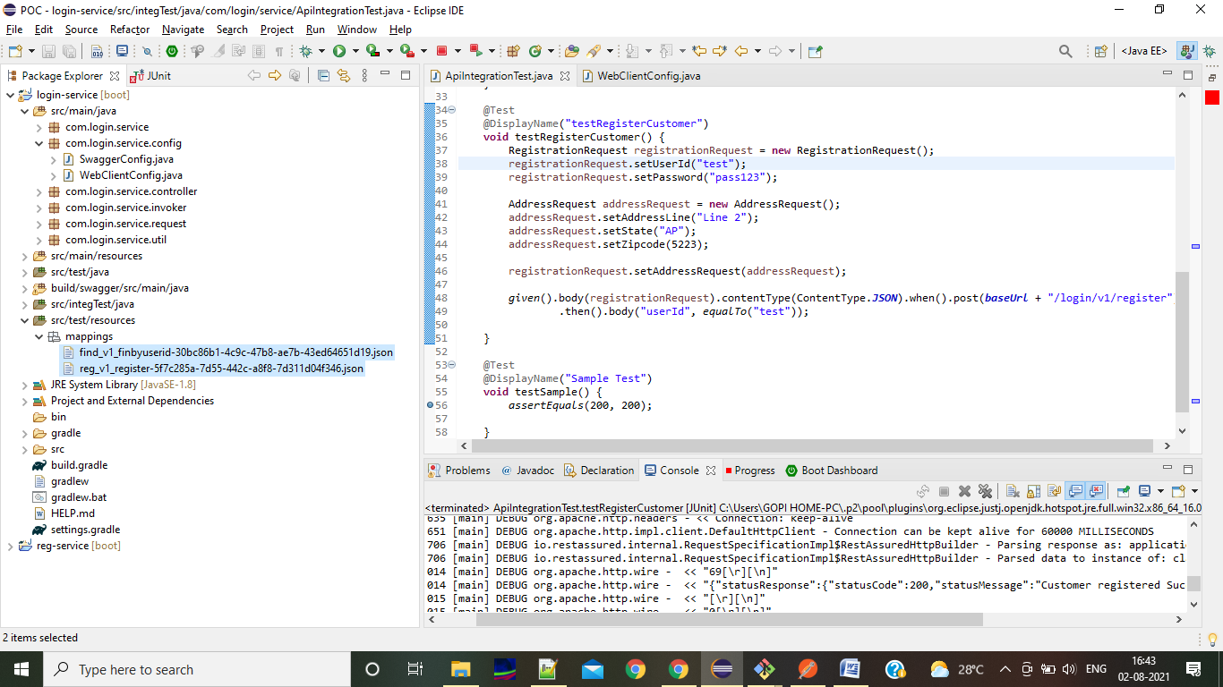

1. For above criteria i need to make these applications (login-service & Wire Mock server) up and running.

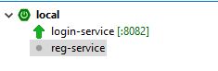

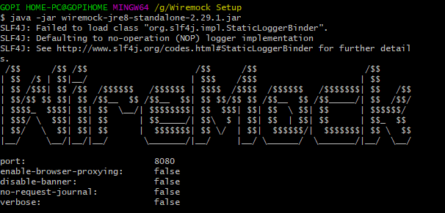

1. In the ApiIntegrationTest.java class given the base url as login-service endpoint as i want to invoke the reg-service,

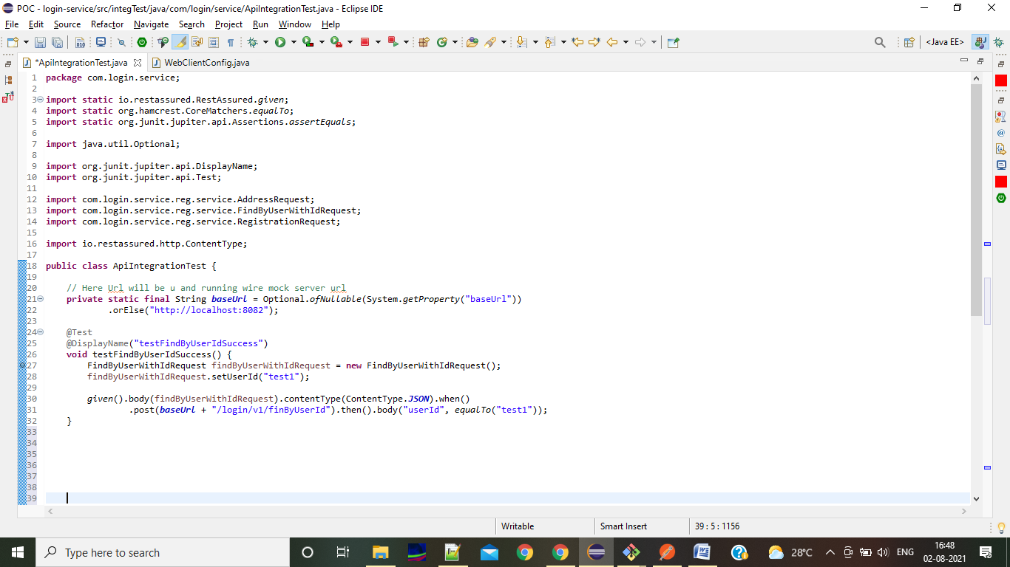

1. In the WebClient configuration class calling the wire mock running url instead of reg-service url,

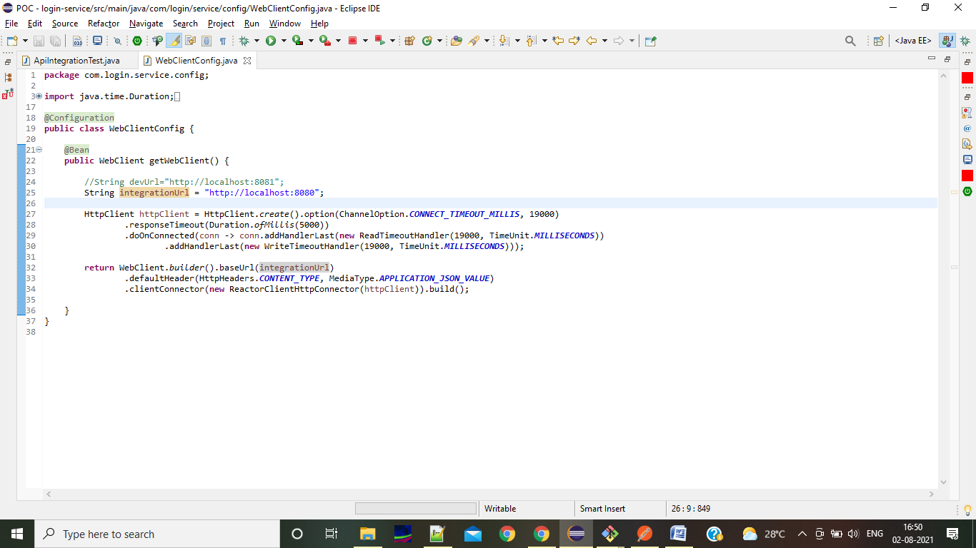

1. To run the integration test cases we need to run **./gradlew clean build integrationTest.**

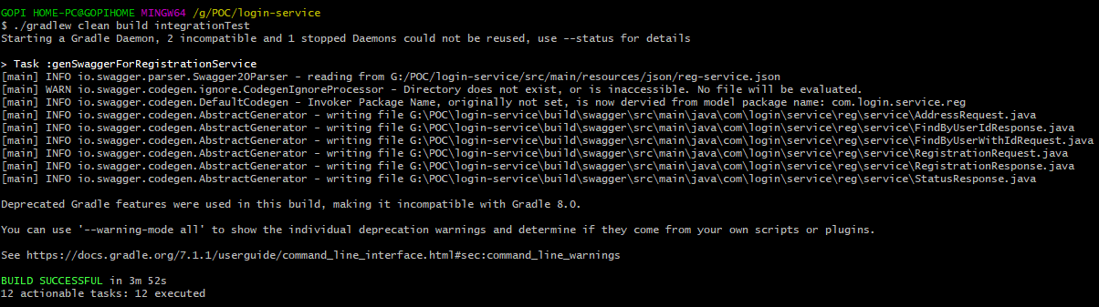

1. After running from STS we will see below in STS,

